Request for Tuition Assistance Benefits

Smith's commitment to academic achievement and lifelong learning is what we are all about. In support of this commitment, we make a significant investment in providing employees with rich opportunities for professional growth and development. Tuition assistance is available to eligible employees, their spouse, and their children.
This document describes the process in Workday for requesting Tuition Assistance Benefits. Please note that you must still meet the eligibility requirements for the specific benefit you are requesting. If you are not eligible, your request will not be fulfilled. Prior to submitting your request, we encourage you to review the full program details including eligibility requirements online at https://www.smith.edu/about-smith/hr/benefits.

Step 1: Log into Workday. You will be taken to your Home page, as shown below.
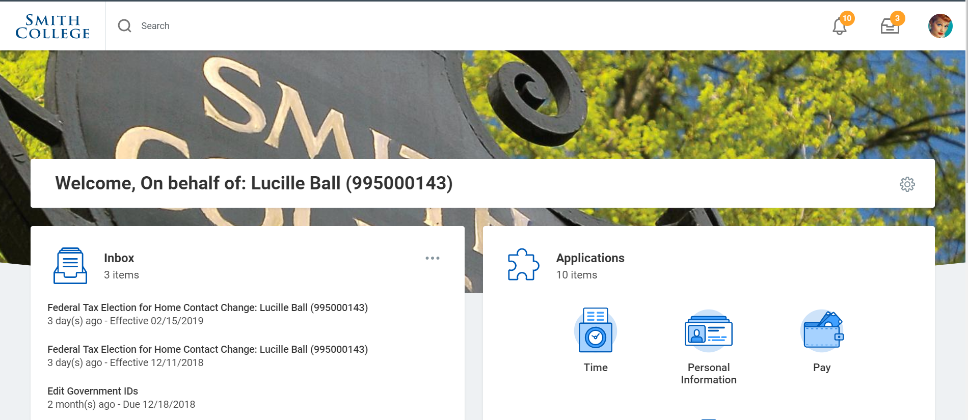

Step 2: Scroll down on the page until you see the Requests icon. Click this icon.
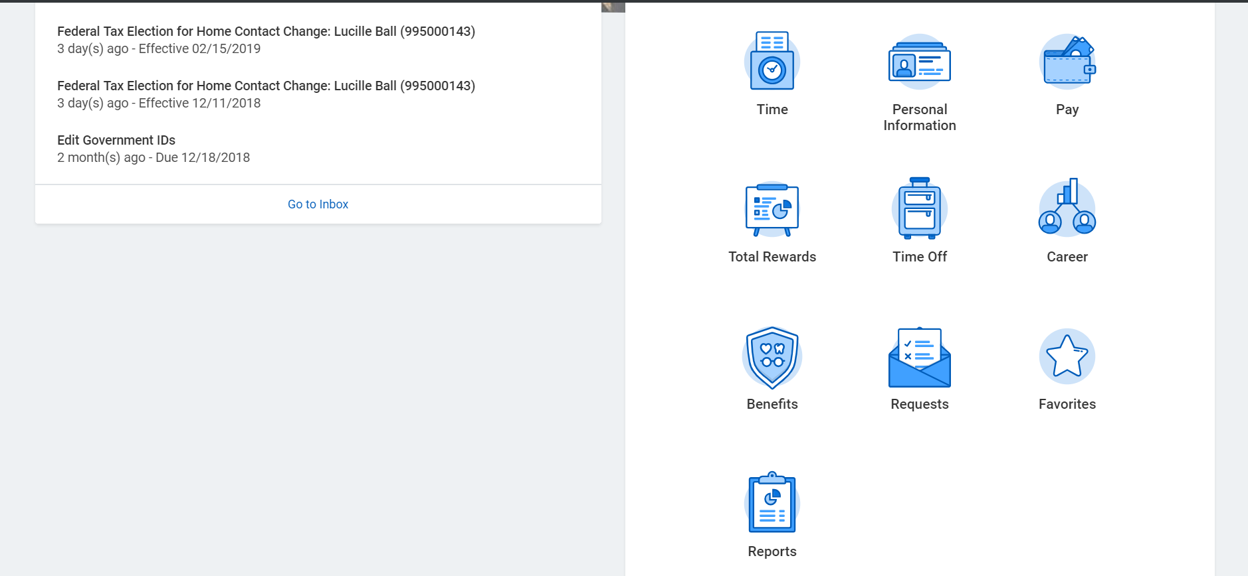

Step 3: On the Requests dashboard, click the action “Create Request.”
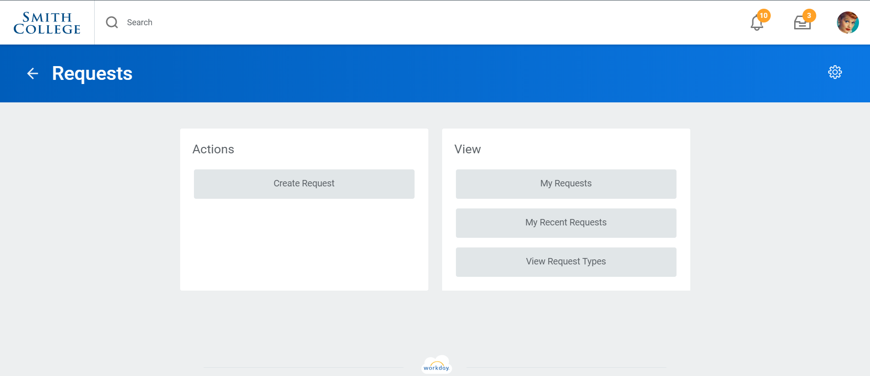
Step 4: Choose the appropriate Request Type based on the tuition request you would like to submit (Employee Classes at Smith Tuition Request or Spouse Classes at Smith). Click OK. [Note: depending on your role in Workday, you may see other request types here unrelated to Tuition Benefits.]
Step 5: Complete the required information, which varies by tuition type, then Submit your request.
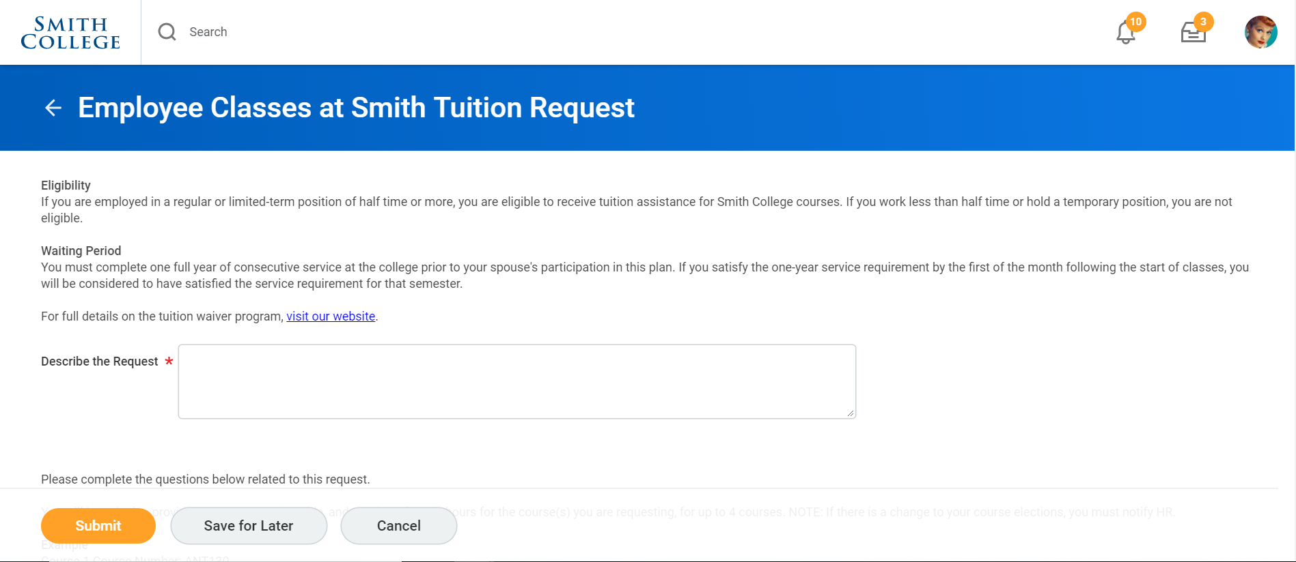
Step 6: That’s it! You will receive a confirmation message once your request has been approved.

